|  |  |  |
| --- | --- | --- |
|  | Workshop 5  Graphic elements in technical reports & talks | T-316-LABB Fall 2023 |

## Summary

We define *graphic elements* of talks and reports to include all schematics, graphs, tables, photographs, and equations. A graphic element is *effective* when it clearly contributes to the author's argument.

After completing the workshop, students should be able to critique and edit schematic diagrams, equations, and graphs for more effective communication.

Please create a complete hard copy solution for your notes. Nothing is turned in for a grade, but you will be tested on this material.

|  |  |
| --- | --- |
|  | Activity 1—Schematics for presenting an apparatus  Compare original to revised. |
|  | Activity 2—Equations as part of an argument  Compare original to revised. |
| Capture.jpg | Activity 3— Graphs as part of an argument  Compare original to revised. |
|  | Activity 4— Practice exercise  Prepare separate graphs for a report and a talk. |

# Activity 1− Schematics for presenting an apparatus

## Original photograph and text

The purpose of this step (a drying process) is to remove excess solvent. This step stabilizes the resist film at room temperature. There are four major effects of removing solvent from a photoresist film: (1) the film thickness is reduced, (2) post-exposure bake and development properties are changed, (3) adhesion is improved, and (4) the film becomes less tacky, and thus less susceptible to particulate contaminant. The bake is performed on a hot plate which will be found in the hood. The bake temperature is about 100 degrees C for forty five seconds.

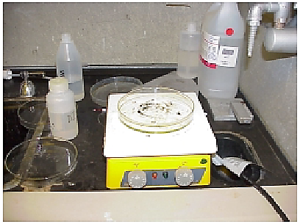

**Figure 4.** Hot plate for baking photoresist.

## Revision

The purpose of the "bake" is to remove excess solvent to stabilize the resist film. The bake is performed on a hot plate (under the hood) at 100C for 45 sec. The components of the hot plate are shown in Figure 4.

revised hot plate dwg v2.emf



**Figure 4.** Hot plate set-up for baking photoresist.

## Questions

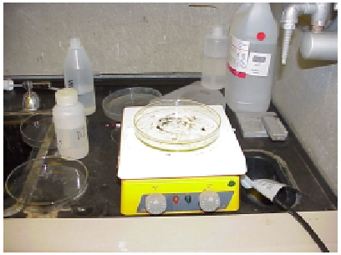Compare the original figure to the revised figure and answer the questions below.

1. What is the purpose of each knob on the hotplate?
2. How would you know if the hotplate were at a hot temperature?
3. What is the purpose of the Petri dish?
4. In what ways is the revised figure an improvement?
5. If the photograph were included in the lab manual, list two ways it could be improved to meet our communication goals.

# Activity 2− Equations as part of an argument

## Original argument with computer code

The calculation for pressure loss through the fluids involves both the major and minor friction losses throughout the entire network of shell and tubes. The major losses include the overall friction of the pipe walls. The minor losses include all of the losses involved with fittings, inlets and outlets, and piping reductions and additions.

"Friction factors"

epsilon_t = 0.000005

f_t = (-2 * log10( epsilon_t/ID_t/3.7065 - 5.0452 / Re_t

* log10( (epsilon_t/ID_t)^1.1098 / 2.8257 + 5.8506/Re_t^0.8981)))^(-2)

f_s = exp( 0.576-0.17*ln(Re_s) )

"Major loss pressure drops"

g_c = 32.174*Convert(ft/s^2,ft/hr^2)

dP_t_maj = rho_c * V_t^2 * (f_t*L/ID_t+4)* N_p / (2*g_c)

dP_s_maj = rho_w * V_s^2 * D_s*f_s*(N_b+1) / (D_e*2*g_c)

## Revision

In a heat exchanger arrangement, cold fluid flows through the tube side (subscript *t*). Pressure drop in the tube due to major losses is modeled by

 (1)

where friction factor is determined using the Chen equation,k

, (2)

in which the surface roughness is assumed to be *εt* = 5×10 in. Warm fluid flows through the shell (subscript *s*). The pressure drop in the shell due to major losses is modeled by

. (3)

The shell surface is smooth, so the friction factor can be modeled using

. (4)

## Questions

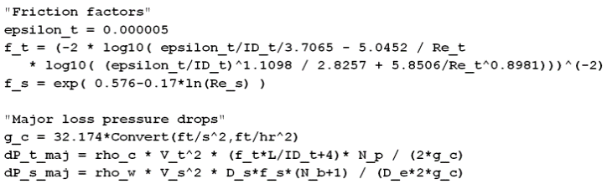Compare the original discussion to the revised discussion and answer the questions below.

1. All other conditions being the same, what effect would doubling the velocity of the cold fluid have on the pressure drop in the tube fluid?
2. What is the surface roughness of the tube material?
3. Suppose the Reynolds number of the shell fluid is doubled. Does the friction factor in the shell fluid increase or decrease?
4. In what ways is the revised discussion an improvement?
5. Rewrite these equations using correct mathematical syntax.
6. 



1. 



1. 



# Activity 3− Graphs as part of an argument

## Original graph and discussion

The increase in the heat transfer coefficient for different values of tube inclination with respect to heat flux is shown on Figure 2. It represents the effect of heat supplied on the fully developed heat transfer coefficient for the test section of 20 degree inclination, 12 mm side square tube, and 1.5 m length.

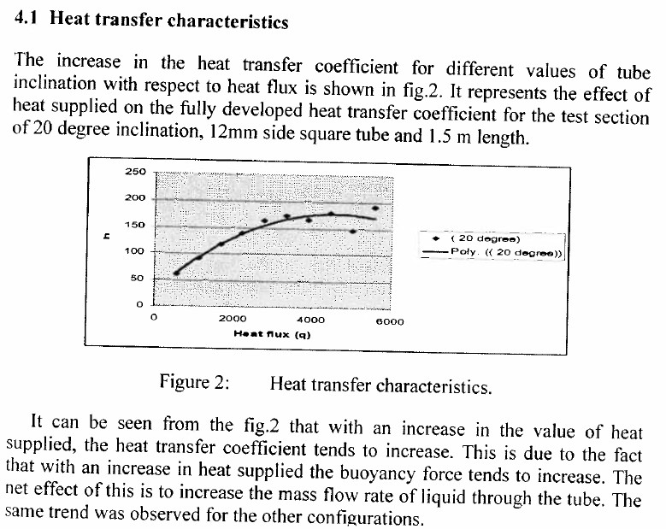

Figure 2. Heat transfer characteristics.

It can be seen from the figure that with an increase in the value of heat supplied, the heat transfer coefficient tends to increase. This due to the fact that with an increase in heat supplied the buoyancy force tends to increase. The net effect of this is to increase the mass flow rate of liquid through the tube. The same trend was observed for other configurations.

## Revision

The effect of heat flux on heat transfer coefficient is shown in Figure 2. The test section is a 12-mm square tube with a total length of 1.5 m at an inclination angle of 20°. The flow is considered to be fully-developed throughout.

|  |  |
| --- | --- |
| Heat transfer  coefficient  (W/m2K) | Heat flux (kW/m2)  Figure 2: Heat transfer characteristics for fully-developed flow at an inclination angle of 20°. |

Figure 2 shows that larger heat fluxes generally increase the heat transfer coefficient. However, at higher values of heat flux the trend in the data is less clear than at lower values of heat flux.

## Questions

Compare the original graph to the revised graph on the previous page and answer the questions below.

1. What is your best estimate the heat transfer coefficient in W/m2K for a heat flux of 0.5 kW/m2?
2. How would you expect the heat transfer coefficient at 8 kW/m2 to compare to the heat transfer coefficient at 4 kW/m2? (circle one) Explain.
   1. greater than
   2. less than
   3. equal
   4. cannot determine
3. Is the polynomial curve-fit plausible? Explain.
4. Your internship supervisor asks you to scan the graph and send it to a client as a PDF file. Which graph do you choose and why?
5. In what ways did the improved version exhibit superior communication?

# Activity 4 − Practice exercise

Given a draft report section and a draft graph, you will

* Edit the graph and import it to the report.
* Edit the graph again and import it to a presentation slide.

Hints

* The conventional scales for frequency response plots are *semi-logarithmic*.
* Nomenclature: natural frequency n , damping ratio , time constant , transfer function *H*(*s*).
* For assigning significant figures to scales, assume uncertainties are known: ± 2 dB and ± 1 rad/s

Download to the same directory

* Word file *practice report.docx*



* Excel spreadsheet *practice data and graph.xlsx*



* starter m-file *W5graphics.m*



* PowerPoint file *practice slide.pptx*



The graph has been started for you in Excel and MATLAB. You can do the work using *either* package.

* In Excel *or* MATLAB, edit the graph to comply with the *Guidelines for Graphics.*
* In a new file, make a new version of the graph to be used in a presentation slide.
* Skim the *Principles of Design* handout. Revise both graphs to comply with the requirements.

The most common error in graphs in presentation slides is undersized fonts. To check that you meet the minimum requirement, put a temporary text box in the slide next to some numbers or text in the graph. In the text box, type text or numbers to match the text or numbers on the graph. Correctly size the text in the text box (18 pt min.) and compare side-by-side to the text of your graph. If necessary, correct your graph in the original software package and paste a new copy into the presentation slide. Check again.

In the report

* Insert the graph in the appropriate location.
* Edit equation (2) using (1) as a guide. Equation (1) is correctly formatted.

In the presentation slides

* Insert the new graph into the PowerPoint slide.
* Write a slide title as a complete sentence (assertion) that states the main point.